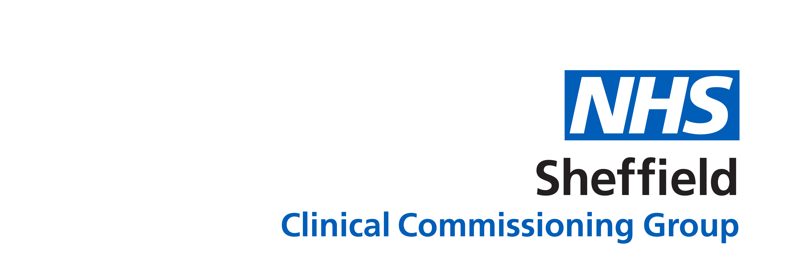
GP practices have changed. This leaflet explains what has changed and why.

What has changed?
- No walk-ins. At most GP practices, you can’t walk in without an appointment. The doors may be closed or locked.
- Strict social distancing. There are less patients and staff in the building.
- Face masks. Everyone aged over 12 should wear a face mask, unless there is a medical reason not to.
- Telephone reviews. We talk to patients on the phone first, to decide what type of appointment they need.
- More telephone and video appointments.

What has stayed the same?
- We are providing the same high level of care that we have always provided. The way we do appointments has changed, but the care and treatment is the same.
- Face to face appointments are still available for people who need them.
- GPs are still doing home visits when needed.

Why have these changes been made?
- Our top priority is to keep patients safe.
- Phone and video appointments are safe and effective. If we need to see you face to face we will, but often, we can get all the information that we need by talking to you.
- When patients come into the practice, we have to clean frequently. We have to put on and take off personal protective equipment, which takes time. We can treat more patients when we do phone and video appointments.
- Social distancing - we are keeping the number of people in GP practices low so that there is plenty of space.
- Across Sheffield, lots of GP practice staff are isolating because they have COVID-19 symptoms or a positive test. We need to keep staff safe to keep services running.
- We have worked hard in a difficult situation to come up with new innovative ways of working so that we can treat patients safely during the COVID-19 pandemic. We are proud of how well GP practices have adapted.

Our promise to you
- We will continue to work hard to keep you safe and provide safe, effective and compassionate care. We are here for you.

What we ask from you.
- Please don’t go to your GP practice if you have COVID symptoms or a positive test.
- Our phone lines are very busy. Please book appointments online if you can.
- Information about COVID restrictions, getting a test, self-isolating and facemask exemptions is online at www.gov.uk/coronavirus, or from the Sheffield City Council helpline 0114 273 4567 . Please don’t phone your practice for this information.
- If you need advice on minor illness, such as diarrhoea, skin conditions, or conjunctivitis you can contact a pharmacy instead of your GP practice.
- We know that things aren’t perfect. Sometimes it is hard to get through on the phone and some patients don’t like phone and video consultations. Please be patient – we are working hard to provide a good service in a very challenging situation.
- There has been an increase in patients being rude and abusive to staff. We understand that patients are in stressful and difficult situations but we will not accept abuse of staff.
The majority of our patients are polite and supportive and we want to say a huge thank you for adapting to the changes that we have made and for working with us.

